**REGISTER FOR IBM CLOUD**

# ISHWARYA S

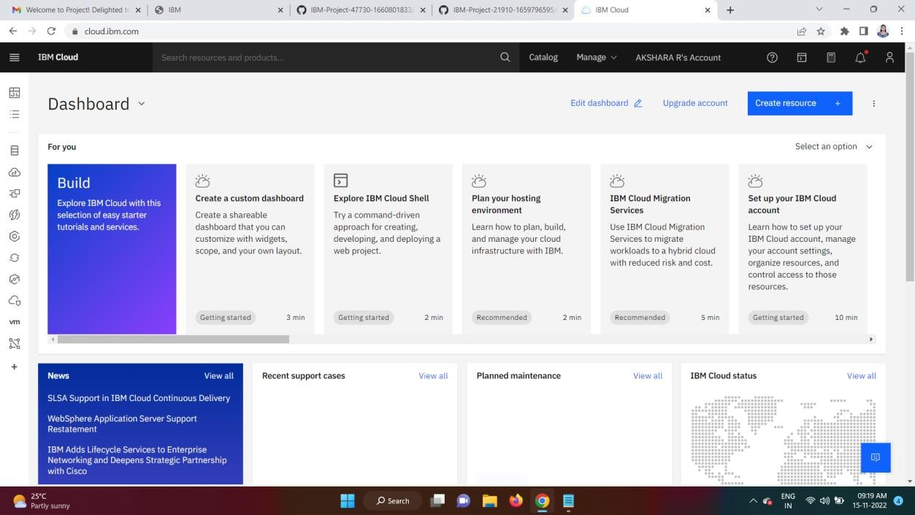

# MONISHA DEVI T

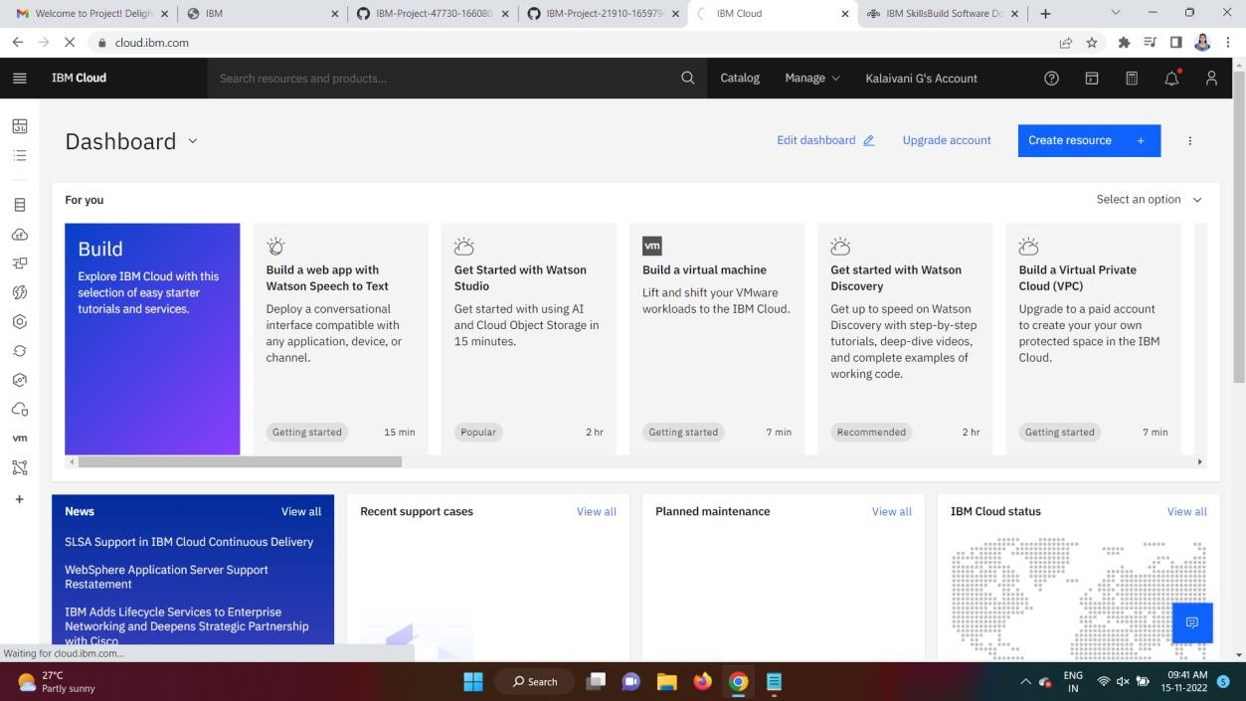

# SHAFRIN SAMEEMA

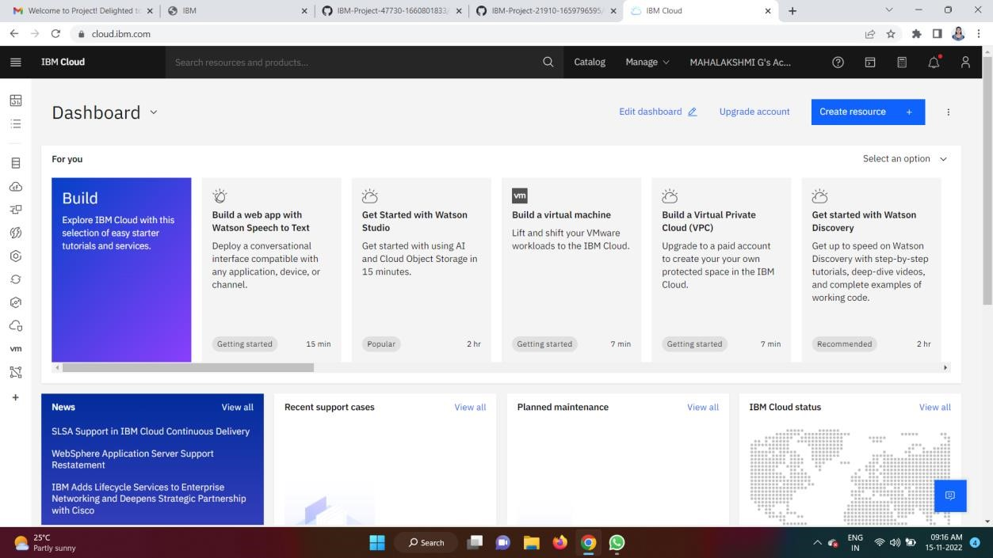

# SWATHI K

